1.8 PUZZLE PROGRAM
Aim
To solve the 8-Puzzle Problem using Python by arranging the tiles in the correct order.
Objective
- To understand the working of the 8-Puzzle Problem.
- To represent the initial state and goal state of the puzzle.
- To verify whether the goal state has been reached using a Python program.
Algorithm
- Define the initial state of the 3×3 puzzle.
- Define the goal state of the puzzle.
- Display the initial puzzle state.
- Move the blank tile (0) down by swapping it with tile 5.
- Display the puzzle after the first move.
- Move the blank tile right by swapping it with tile 8.
- Display the puzzle after the second move.
- Compare the current puzzle with the goal state.
- If both states are equal, display "Goal State Reached".
- Stop the program.
Flowchart
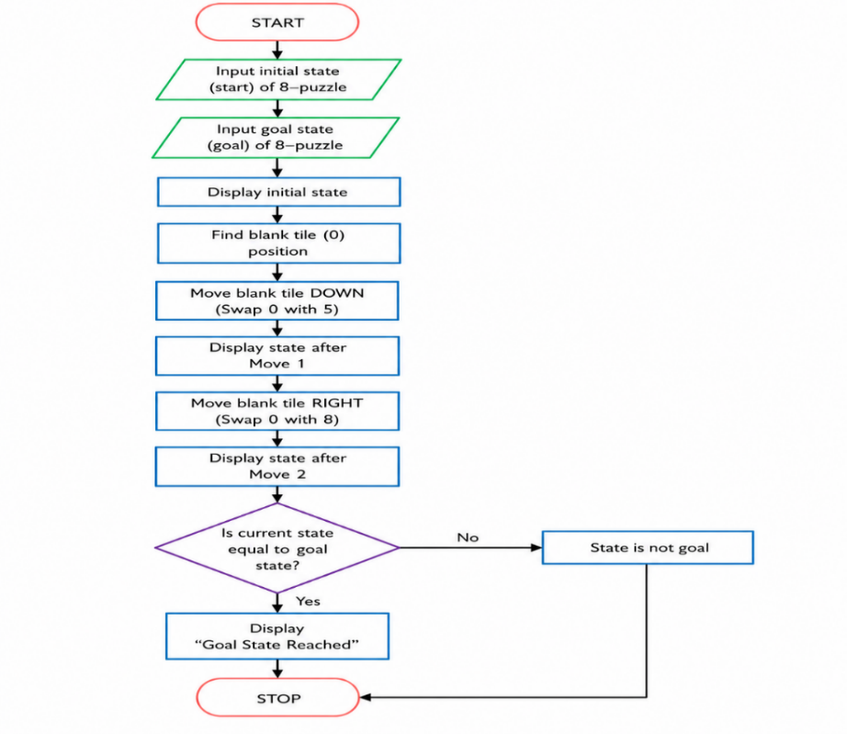

Code
def print_broad(board):
for row in board:
print(row)
print()
def solve():
start=[[1,2,3],[4,0,6],[7,5,8]]
goal=[[1,2,3],[4,5,6],[7,8,0]]
print("Inital State:")
print_broad(start)
start[1][1], start[2][1] = start[2][1], start[1][1]
start[2][1], start[2][2] = start[2][2], start[2][1]
print("Goal Start:")
print_broad(start)
if start==goal:
print("goal reached")
solve()
Output
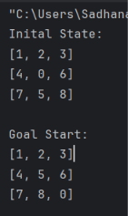
Result
The 8-Puzzle Problem was successfully implemented in Python. The program transformed the initial state into the goal state by making the required tile moves and displayed "Goal Reached", confirming that the goal state was achieved successfully.

